1. Debugging Techniques
Explanation
Debugging techniques are methods used to identify, locate, and correct errors in software or hardware during system development. In embedded systems, debugging is very important because both hardware and software are tightly integrated. If both parts are incorrect, it becomes difficult to find the source of the problem. Therefore, developers try to test software and hardware separately before integrating them.
The main goal of debugging methodology is to reduce the introduction of untested components into the system. When new hardware and new software are combined at the same time, unexpected problems may occur. To avoid this, developers simulate and test different parts of the system before actual deployment. Simulation tools allow developers to test software behaviour without using the real hardware.
Debugging also improves the reliability and performance of the system. It helps detect logical errors, memory problems, communication failures, and timing issues before the final product is released.
Real Example
While developing a drone flight controller, engineers first test the control algorithm using simulation software before connecting the real motors and sensors.
Diagram – Debugging in Embedded Development
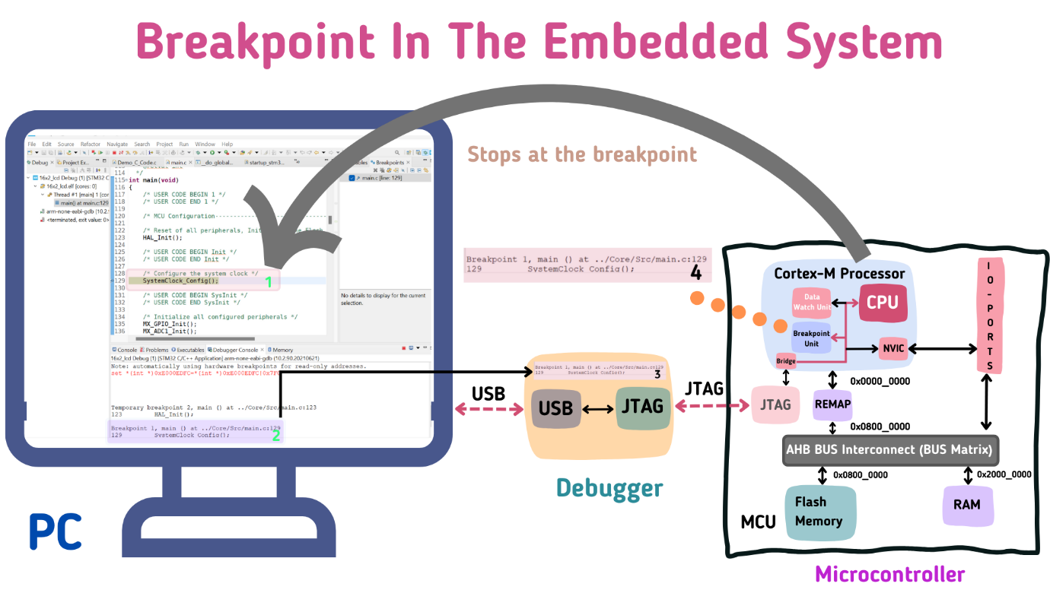

2. High Level Language Simulation
Explanation
High level language simulation refers to the technique of testing embedded software using high-level programming languages such as C or C++ without requiring the actual hardware. In this method, the program is executed on a general-purpose computer such as a PC or workstation.
If the software does not depend heavily on hardware-specific input/output operations, large portions of the program can be tested on another system. This allows developers to simulate inputs and verify program logic before deploying the software to the embedded hardware.
One advantage of this method is that software and hardware can be developed in parallel. While hardware engineers design the circuit board, software developers can continue writing and testing code on a computer.
Input/output operations can be simulated using keyboard input, test data tables, or software models. However, this method has limitations. If the program uses non-standard libraries or hardware-specific functions, it may not run correctly on the target embedded system.
To solve this problem, developers try to use the same system libraries or operating system interfaces that exist in the target system. Many UNIX-compatible systems support portable software development, allowing code to be transferred easily between systems.
Example
Testing a sensor data processing algorithm on a PC before loading it into a microcontroller.
Diagram – High Level Simulation

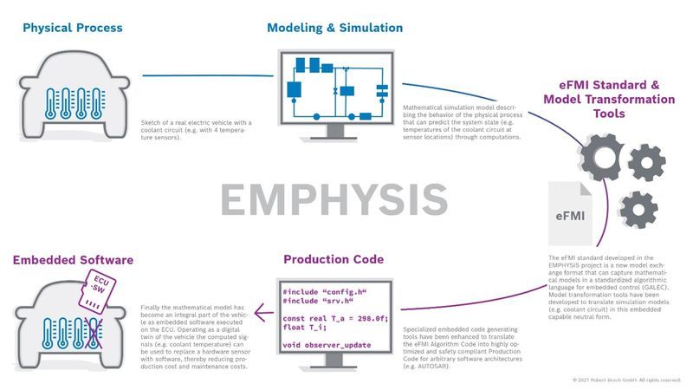
3. Low Level Simulation
Explanation
Low level simulation focuses on simulating processor instructions, memory behaviour, and hardware operations. Unlike high-level simulation, this method allows developers to test assembly language code and low-level routines such as initialization programs.
A CPU simulator models the behaviour of the processor, memory system, and sometimes peripheral devices. This allows low-level code to be executed and tested without using actual hardware.
Low-level simulation tools usually fall into two categories:
1. Functional Simulators
These simulate the programming model of the processor and memory. They provide debugging features similar to onboard debuggers, allowing developers to step through instructions and observe register values.
2. Timing Simulators
These simulators provide timing information such as clock cycles, cache behaviour, and memory access time. This helps developers analyze system performance and make hardware design decisions.
Although low-level simulation is useful, it is generally slower than real hardware execution and may not always provide accurate timing information.
Example
Simulating a Motorola MC68000 processor instruction execution using a CPU simulator.
Diagram – Low Level Simulation

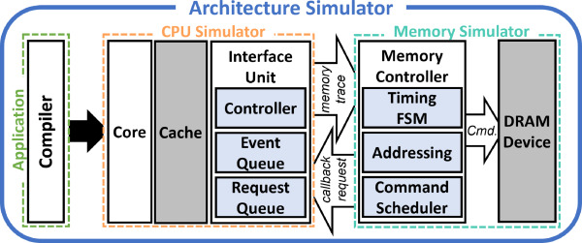

4. Onboard Debugger
Explanation
An onboard debugger is a debugging system that runs directly on the embedded hardware board. It provides a very low-level method for debugging embedded software.
The onboard debugger is usually implemented as firmware stored in EPROM or ROM, or as software routines integrated with the application code. These debugging routines communicate with a PC or workstation through a serial connection or communication interface.
The onboard debugger performs several important tasks:
Hardware Initialization
It initializes the processor and board hardware to ensure the system starts in a known state.
Debugging Support
It provides debugging functions such as breakpoints, memory inspection, and register access.
Code Downloading
It allows developers to download software to the embedded board using communication interfaces.
Although onboard debugging is simple and inexpensive, it is usually less powerful than advanced symbolic debugging systems.
Example
Debugging firmware on an ESP32 development board using a serial debug monitor.
Diagram – Onboard Debugger

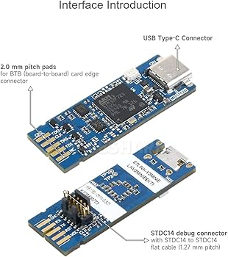
5. Task Level Debugging
Explanation
Task level debugging is used when an embedded system runs under a real-time operating system (RTOS). Instead of debugging individual machine instructions, developers can debug tasks and system events.
In many systems, low-level debuggers are insufficient because they cannot monitor the behaviour of tasks, messages, or interrupts in an RTOS environment. Task level debugging tools operate at the operating system level and provide detailed information about task execution.
Task level debugging provides features such as:
• Setting breakpoints on tasks or events
• Monitoring inter-task communication
• Tracking interrupts and system messages
• Displaying task status and memory usage
This allows developers to observe how tasks interact with each other and identify synchronization problems or scheduling issues.
Example
Debugging tasks in a FreeRTOS-based robotic control system.
Diagram – Task Level Debugging
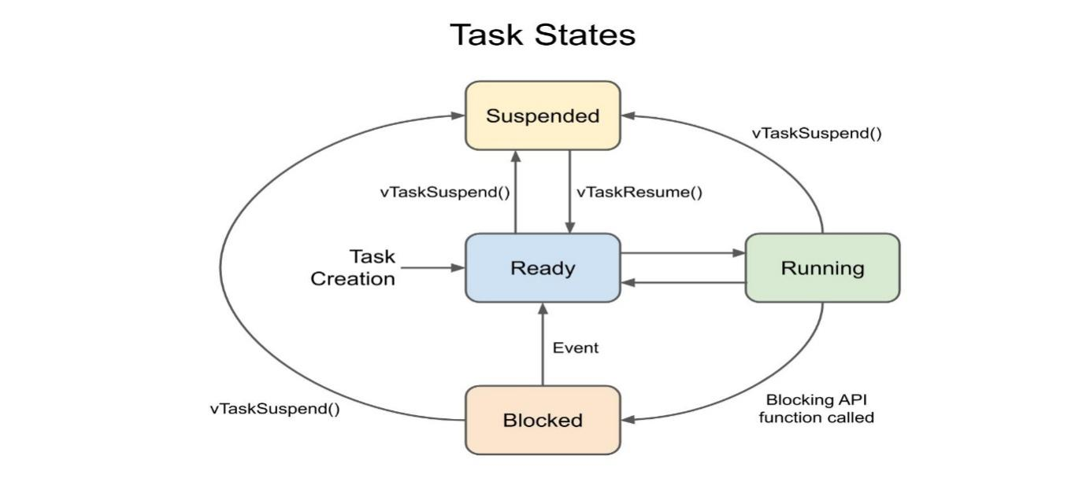
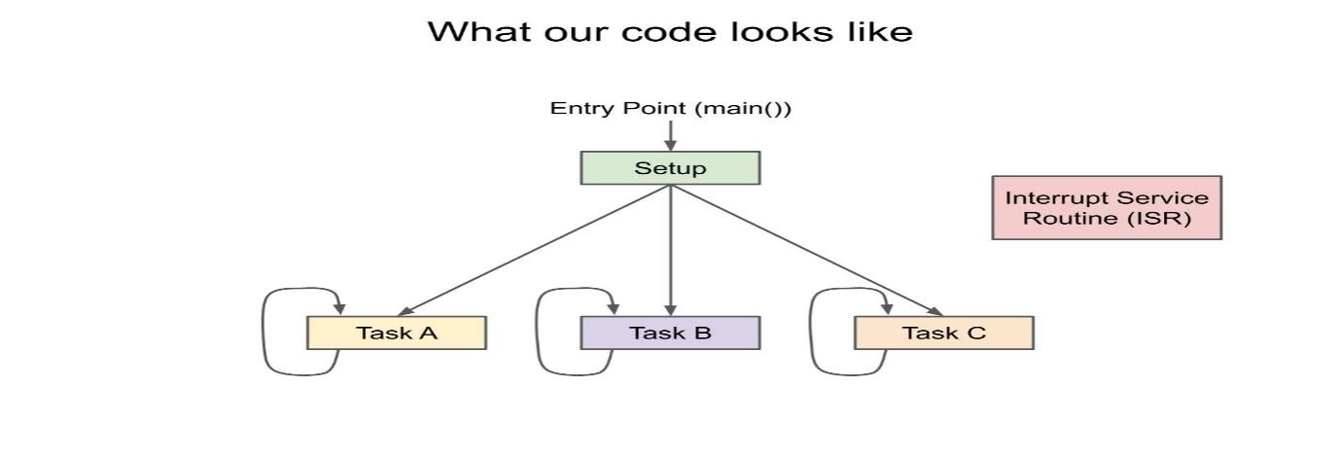

7. Emulation
Explanation
Emulation is a technique in which a special hardware device called an emulator replicates the behaviour of the target processor. This allows developers to run and debug embedded software in the actual hardware environment.
The most common form is In-Circuit Emulation (ICE), where the emulator replaces the processor in the target system. It allows developers to observe internal processor signals, monitor memory activity, and control program execution.
Emulation is particularly useful when developers need detailed timing information or real-time debugging capabilities.
However, modern processors increasingly integrate debugging features directly on the chip, reducing the need for external emulators.
Example
Using an ARM hardware emulator to debug firmware running on an embedded board.
Diagram – Emulation System
